**GROUP CASE 1: DESCRIPTIVE ANALYSIS OF CRUSTY PIZZA RESTAURANTS AND THEIR SUCCESS FACTOR CONTRIBUTION**

**By**

Taylor Millwood

Steven Faurot Jr

Jacob Malarik

Pradeepika Ravala

**MBA 624: BUSINESS ANALYSIS FOR DECISION MAKING**

**PROFESSOR: IVANA SAVIC**

**BELLEVUE UNIVERSITY**

**JUNE 27, 2019**

**ABSTRACT**

Crusty Pizza Restaurant has approximately 60 stores across various locations that offer wide varieties of pizzas to customers. The management of the company has provided us with the primary data available on all 60 stores and wanted to identify and analyze which factors have a greater influence on the success and unsuccess of the store. In the document presented through this case, we use different kinds of descriptive statistics tools like mean, median, correlation coefficient, covariance, etc., to analyze the influence of each factor on the monthly profit.

**TABLE OF CONTENTS**

|  |  |
| --- | --- |
| ***1.* *Introduction*** | **5** |
| ***2.* *Case Overview*** | **5** |
| ***a.*     *Factors Mentioned*** |  |
| ***b.*     *Store Ranking*** |  |
| ***3.* *Methods of Calculation*** | **6** |
| ***4.* *Factor Analysis*** | **6-13** |
| ***a.*     *Exhibit 1: Profit Vs Population*** |  |
| ***b.*     *Exhibit 2: Profit Vs Monthly Advertising Expenses*** |  |
| ***c.*     *Exhibit 3: Profit Vs Size*** |  |
| ***d.*      *Exhibit 4: Profit Vs Competitors*** |  |
| ***e.*     *Exhibit 5: Profit Vs Seating*** |  |
| ***f. Exhibit 6: Profit Vs Other Factors*** |  |
| ***5.* *Conclusion*** | **14** |
| ***References*** | **15** |
| ***List of Tables*** |  |
| ***1.* *Table 1:* Various factors and their respective statistical analysis w.r.t profit** | **11** |
| ***2.* *Table 2:* The statistical analysis of all the order options w.r.t monthly profit** | **13** |
| ***List of Diagrams / Graphical Notations*** |  |
| ***1.* *Figure 1: Effect of population on monthly profit*** | **7** |
| ***2.* *Figure 2: Effect of the student population on monthly profit*** | **7** |
| ***3. Figure 3: Effect of Advertising on monthly profit*** | **8** |
| ***4. Figure 4: Distribution of profit over various store sizes*** | **9** |
| ***5. Figure 5: The effect of competitors on monthly profit*** | **10** |
| ***6.* *Figure 6: Effect of the parking lot on monthly profit*** | **12** |
| ***7.* *Figure 7: Effect of pizza varieties on monthly profit*** | **13** |
|  |  |
| ***Appendix I*** | **16** |
| ***Appendix II*** | **16** |

**INTRODUCTION**

Statistics is the mathematical science that deals with the collection, analysis, and presentation of data, which can be used as a basis for inference and induction (Donnelly, 2015). The purpose of the case presented here is to identify the factors using statistical tools that make the Crusty Pizza Companies successful and unsuccessful.

**CASE OVERVIEW**

The case presented above consists of primary data on 60 Crusty Pizza Restaurants that were both successful and unsuccessful based on different factors.

**FACTORS MENTIONED:**

Various factors that have an influence on the success of the company that were identified and provided based on the primary data are: store size, seating, liquor license, student population, competitors, pizza varieties, population, delivery option, order option, reviews, monthly advertising expenditure, parking spots, buffet and offer of pizza slice. All the factors have a little more influence on the profit-making of the company. But in the document to proceed, we discuss the five leading factors that have a greater influence on the profit-making of the company, causing them to be successful or unsuccessful factors.

**STORE RANKING:**

Before identifying and analyzing the individual factors, we must sort all the restaurants in the ranking order to determine the best performing and worst performing restaurants. This can be done by simply using sort function either from smallest to largest or vice versa in excel on the monthly profit of the restaurant.

**METHODS OF CALCULATION**

There are many mathematical and EXCEL tools that are used to sort the data and present the analysis of factors to that of profit. This document addresses the mean, median, covariance, correlation coefficient, standard deviation, scatter plots, and frequency. Everything was processed using functions from Microsoft Excel. Every factor is shown in relation to the monthly profit to define the most influencing factor for store success.

**FACTOR ANALYSIS**

**EXHIBIT 1: PROFIT VS POPULATION**

The first step was dividing the locations that earned a profit from those who suffered a loss. Once these were separated, we performed the analyses of mean, median, and range to compare the market that each group of locations was operating in. The locations that were earning a profit were in markets that had an average student/resident population within 20 miles of 13,457 students/315,665 residents. (Appendix I) Unfortunately for the locations that suffered a loss, they tend to have smaller populations with averages of 8,798 students/243,933 residents. That puts these locations at a disadvantage being that the potential customer base is 35% (students)/23% (residents) less than the more successful locations.  The median and range support these findings. If you also view the scatter plot charts below, you will see that there is a positive correlation between a larger population and a more profitable location. Comparing the median data points, the locations that suffered a loss tend to have a difference in the population of 34% instead of the average of 23%. The range data also showed quite a wide range in the population letting us know that there was at least one outlier skewing the data. Taking this into consideration the difference in resident population is going to be closer to the median percentage of 34%, further supporting the argument that they are competing in a significantly smaller market.

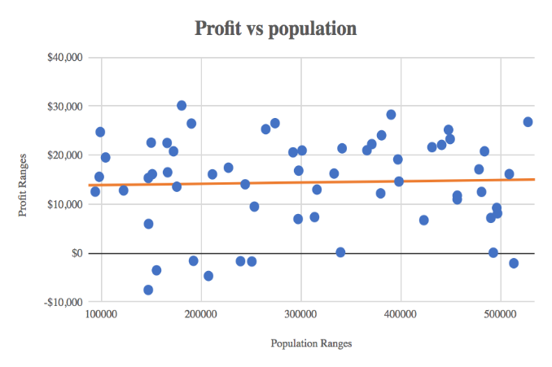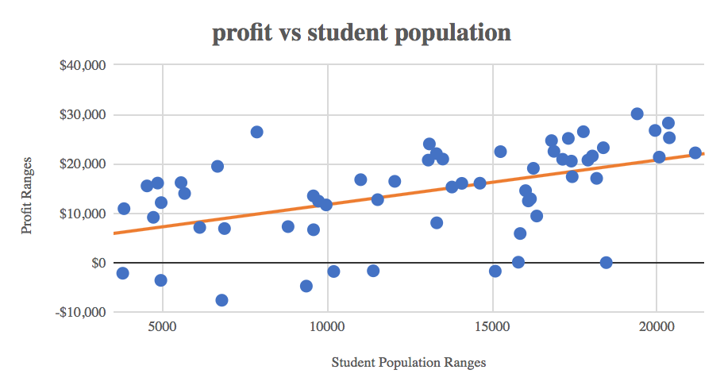

**Figure 1: Effect of Population on Monthly Profit Figure 2: Effect of the student population on monthly profit**

**EXHIBIT 2: PROFIT VS MONTHLY ADVERTISING EXPENSES**

Advertising was discovered to be one of the biggest contributing factors to the success of each store. Each store spent between $824 - $3,192 which makes the range of monthly advertising expenses $2,368. Now, what amount should you be spending to find the most success? If you look at figure (3) you will see that most of the stores spend between $1,500-$2,500. We can also see that the trend between monthly expenditure and monthly profit is in the direction of the more you spend, the more you make. The correlation coefficient for these data sets is 0.77 which means that it has a positive correlation letting us know that if the value of one variable increases the likelihood is that the value of the other increases too. The top 5 stores ranked by profit spent over $2,000 with the exception of the store ranked in the #2 spot, but only by $15, while the lowest 5 ranked stores spent under $1,000 besides the store ranked #56 which spent $1,168. You don’t see a store that spent under $1,000 until the #44 ranked spot which definitely tells you that you should be spending at least $1,000 on advertising a month to have a better chance of profiting that month.

Through excel calculations, we found that the population as a whole had a mean of $1,790.95 and a median of $1,826.50. The stores that made a profit had a mean of $1,895 and a median of $1,902 while the stores that took a loss had a mean of $1,002 and a median of $970. Looking at these numbers it is clear that to have the best chance at making a profit dealing with monthly advertising expenditures, you should spend between $1,500 and $2,000.

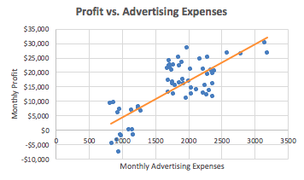

**Figure 3: Effect of Advertising on monthly profit**

**EXHIBIT 3: PROFIT VS SIZE**

The size of the store greatly influences the amount of gross profit.  During our analysis, there’s a correlation to the increase in size that favors an increase in profit.  The very large stores have the highest gross profit average of $18,158.59 and then average monthly profit decreases as the size of the store decreases.

The increase in store size was more consistent profit makers.  There were 19 out of 27 very large stores (70.37%) with a positive z-score compared to 9 out of 13 large stores (69.23%), 3 out of 13 (23.08%) medium stores, 2 out of 7 (28.57%) small stores have positive z-scores.

The covariance of the size compared with the is a positive relationship which indicates that the increase in size has a direct influence on an increase in profit. The correlation is .4143 so it has a moderate positive relationship between the size of the store and the gross profit.

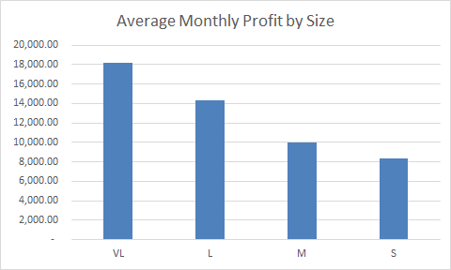

**Figure 4: Distribution of profit over various store sizes**

**EXHIBIT 4: PROFIT VS COMPETITORS**

Now we would like to take a look at the market landscape from a competition point of view. (Appendix II) We found that even though the locations that suffered a loss were in markets that were much smaller, the competition they faced was more densely populated. This was surprising. The locations that made a profit averaged 24% less competition within 2 miles, 17% less within 5 miles, and 19% less within 15 miles. The median was almost exactly the same across the board. What was also surprising upon further inspection, was that the range reinforced that the landscape is consistently more competitive in the smaller markets that the loss locations operated in. These are the range of data sets for the profit/loss of competitive landscapes. (5,2) 2 miles, (8,4) 5 miles, (17,11) 15 miles.

Taking the above data into consideration a major trend seems to be taking place. The stores that are losing money are facing an upward battle. They are fighting for more market share in a landscape that is on average, 20% more competitive. With a significant increase in competition, the end consumer has many more options to choose from. The negative correlation is reflected in the graph below.

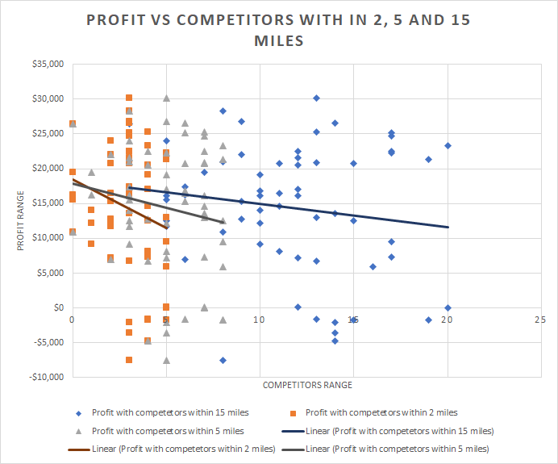

**Figure 5: The effect of competitors on monthly profit**

**EXHIBIT 5: PROFIT VS SEATING**

The profit by whether or not a store provides dine-in seating is directly tied to the store size.  In exhibit 3, there were statistics that supported that the very large stores were the most successful store model. There is dine-in seating only in the very large and large stores.  The small and medium stores are carryout and/or delivery only. Seating brings in additional revenue through the ability to serve a different customer group. Those looking to sit down and have a meal together.  Such as families, local sports teams, church groups, etc. The average store profit of the dine-in stores ($16,912.94) vs those without seating ($9,415.05). This is a difference of $7,497.89. It is fairly easy to equate that stores providing seating have a greater capacity to make a larger profit.

**EXHIBIT 6: PROFIT VS OTHER FACTORS**

The other factors that have less to no effect on the factors include liquor license, pizza varieties, delivery availability, order options, offer pizza slice, parking, buffet, and review. To obtain the covariance and correlation coefficient in the following table, we have assumed one part of the statement “yes / positive” as “1” and “no / negative” as “2”.

|  |  |  |  |  |  |
| --- | --- | --- | --- | --- | --- |
| **Factor** |  | **Mean** | **Median** | **Covariance** | **Correlation Coefficient** |
| **Liquor License** | Yes | 14955.08 | 15712.12 | 270.72 | 0.06 |
| No | 13872.21 | 16089.90 |
| **Delivery Availability** | Yes | 16303.27 | 16819.02 | 1480.21 | 0.39 |
| No | 7581.91 | 9210.90 |
| **Review** | Positive | 14686.98 | 15831.10 | 218.67 | 0.06 |
| Negative | 13320.31 | 16447.55 |
| **Buffet** | Yes | 16613.42 | 17967.40 | 513.28 | 0.13 |
| No | 13744.15 | 15081.85 |
| **Pizza slice Offer** | Yes | 14546.11 | 16951.91 | 97.14 | 0.02 |
| No | 14049.36 | 14682.81 |

**Table 1: Various factors and their respective statistical analysis w.r.t profit**

According to the table mentioned above, we can clearly see that review, pizza slice offer, buffet, and review has a positive effect on the profit of the company. However, the correlation coefficient is very small that the influence of the profit is almost negligible. Even the mean and median are almost equal. Hence, we can conclude that the above four factors have negligible or no influence on the profit.

But then if we look at the correlation coefficient of delivery option, the restaurants with the delivery option has a high influence on the profit. It is almost 0.39% relation between profit and delivery. Hence, we can conclude that adopting delivery method can increase the profit.

**Parking Lot:**

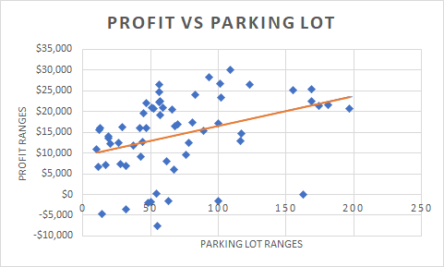

**Figure 6: Effect of the parking lot on monthly profit**

The correlation coefficient of profit vs parking lot is 0.37%. The stores with more parking lots have a positive effect and increasing influence on profit. As the linear line on the graph is a representation of the increasing profit with an increase in the parking lots. However, the parking lot is also dependent on the store size and seating arrangements.

**Pizza Varieties:**

According to the graphical representation of the pizza varieties (Figure 3) and its influence on the profit, the line is almost horizontal. Hence it is considered as no influence on the profit of the company. Even the same is evident from the correlation coefficient. It is 0.02.

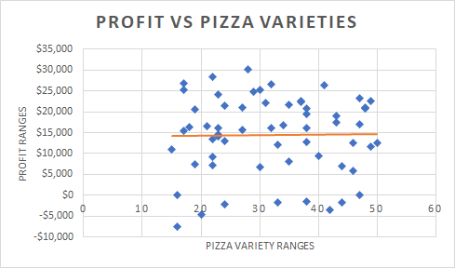

**Figure 7: Effect of pizza varieties on monthly profit**

**Order Options:**

|  |  |  |  |  |  |
| --- | --- | --- | --- | --- | --- |
| Order Option | All | F | T | T&W | W |
| Mean | 14091.87 | 11478.73 | 13626.21 | 17574.46 | 14853.84 |
| Media | 14968.61 | 11717.29 | 16654.33 | 16819.02 | 14853.84 |

**Table 2: The statistical analysis of all the order options w.r.t monthly profit**

The order options have relatively less influence compared to most of the factors. The correlation coefficient, in this case, is only 0.15%. Hence, we can conclude that profit increases with all the options included.

**CONCLUSION**

To summarize, through excel calculations and descriptive statistics, almost all the factors have an influence on the success and unsuccess of the 60 Crusty pizza stores. Even among them, a few of the factors like monthly advertising expenses, student population, size, delivery, competitors, parking lot, seating has a high contribution to the success of the store. However, if we go deep into the analysis, we have an interdependency of one factor on other factors. This is evident from the fact that the factors like the parking lot, seating, etc., are interdependent on the size of the store, which contributes to almost equal strength of correlation to the monthly profit if viewed as individual factors. Through our analysis, we were able to reveal that stores are more profitable with bigger size stores (which in turn provides more seating, more parking lot options), medium to high investment in advertising, high student population, and less competition. If they spend more than $1,000 on the monthly advertisement and preferably between $1,500 and $2,000, and if you are in a higher populated area with less competition, which seems to be more common considering the locations with more competition were also the locations with the smaller population. As a project manager, instead of focusing on all the factors like reviews, pizza varieties, buffet, liquor license etc., which have almost negligible contribution to monthly profit, if we focus on the factors with greater influence like advertising, store size, student population, delivery, competitors the success of the store can be improved in correspondence with the monthly profit of the store.

**References:**

Donnelly, R. A. (2015). *Business Analysis for Decision Making* (1st custom ed.). Boston, MA: Pearson Education. Retrieved from <https://etext.pearson.com/eplayer/> (E-book series)

**Appendix I**

**Population Data Chart**

|  |  |  |  |  |  |  |  |
| --- | --- | --- | --- | --- | --- | --- | --- |
|  | Average Profit | Average Loss | Median Profit | Median Loss | Range Profit | Range Loss | Correlation Coefficient |
| Student Population | 13,457 | 8,798 | 14,624 | 9,362 | 17,318 | 11,292 | 0.497 |
| Population Within 20 Miles | 315,655 | 243,933 | 316,326 | 207,674 | 433,492 | 366,169 | 0.037 |

**Appendix II**

**Competition Data Chart**

|  |  |  |  |  |  |  |  |
| --- | --- | --- | --- | --- | --- | --- | --- |
|  | Average Profit | Average Loss | Median Profit | Median Loss | Range Profit | Range Loss | Correlation Coefficient |
| Competition 2 Miles | 2.8 | 3.7 | 3 | 4 | 5 | 2 | -0.215 |
| Competition 5 Miles | 4.9 | 5.9 | 5 | 5 | 8 | 4 | -0.163 |
| Competition 15 Miles | 11.3 | 13.9 | 11 | 14 | 17 | 11 | -0.163 |